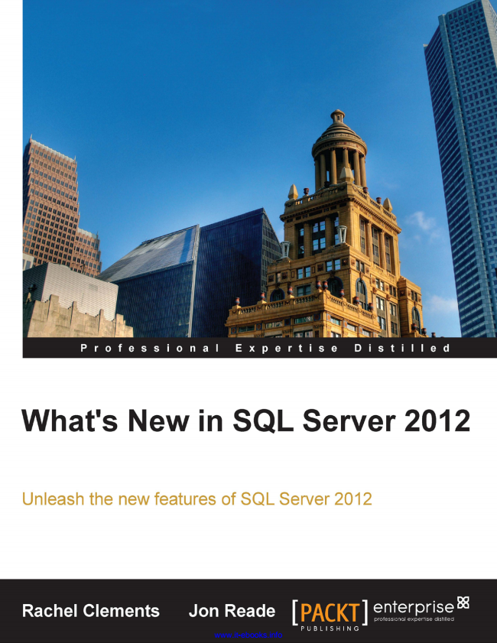

www.it-ebooks.info

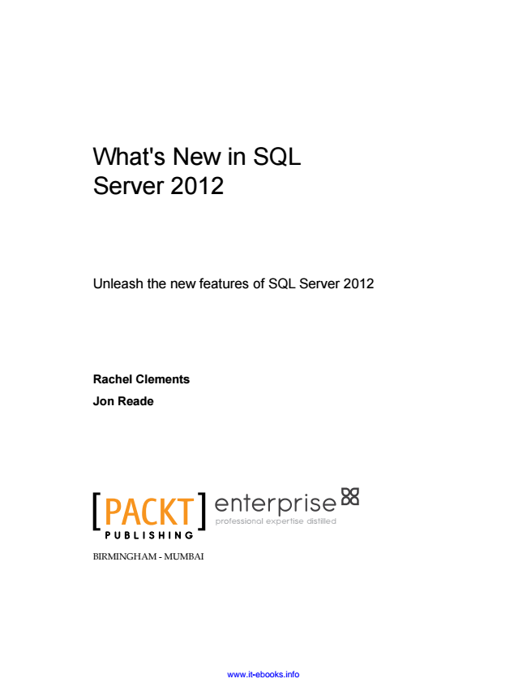

What's New in SQL Server 2012

Unleash the new features of SQL Server 2012

**Rachel Clements**

**Jon Reade**

P U B L I S H I N G

professional expertise distilled

BIRMINGHAM - MUMBAI

www.it-ebooks.info

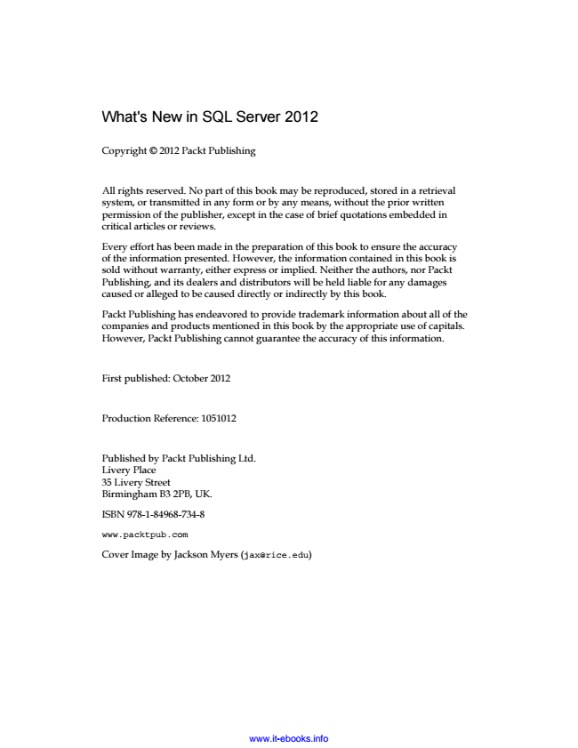

What's New in SQL Server 2012

Copyright © 2012 Packt Publishing

All rights reserved. No part of this book may be reproduced, stored in a retrieval system, or transmitted in any form or by any means, without the prior written permission of the publisher, except in the case of brief quotations embedded in critical articles or reviews.

Every effort has been made in the preparation of this book to ensure the accuracy of the information presented. However, the information contained in this book is sold without warranty, either express or implied. Neither the authors, nor Packt Publishing, and its dealers and distributors will be held liable for any damages caused or alleged to be caused directly or indirectly by this book.

Packt Publishing has endeavored to provide trademark information about all of the companies and products mentioned in this book by the appropriate use of capitals. However, Packt Publishing cannot guarantee the accuracy of this information.

First published: October 2012

Production Reference: 1051012

Published by Packt Publishing Ltd. Livery Place 35 Livery Street Birmingham B3 2PB, UK.

ISBN 978-1-84968-734-8

www.packtpub.com

Cover Image by Jackson Myers (jax@rice.edu)

www.it-ebooks.info

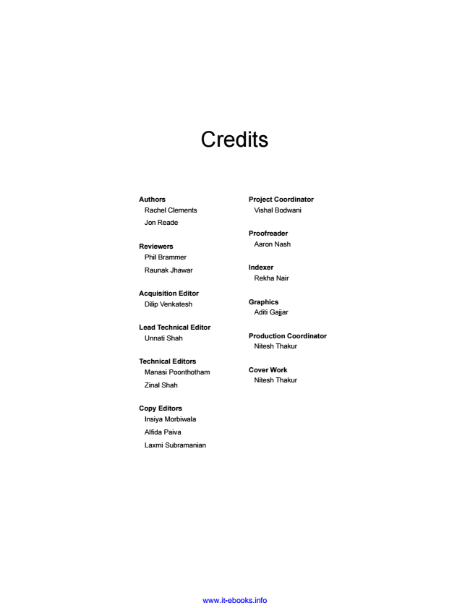

Credits

**Authors**

Rachel Clements

Jon Reade

**Reviewers**

Phil Brammer

Raunak Jhawar

**Acquisition Editor Dilip Venkatesh**

**Lead Technical Editor**

Unnati Shah

**Technical Editors**

Manasi Poonthotham

Zinal Shah

**Copy Editors**

Insiya Morbiwala

Alfida Paiva

Laxmi Subramanian

**Project Coordinator**

Vishal Bodwani

**Proofreader**

Aaron Nash

**Indexer**

Rekha Nair

**Graphics**

Aditi Gajjar

**Production Coordinator**

Nitesh Thakur

**Cover Work**

Nitesh Thakur

www.it-ebooks.info

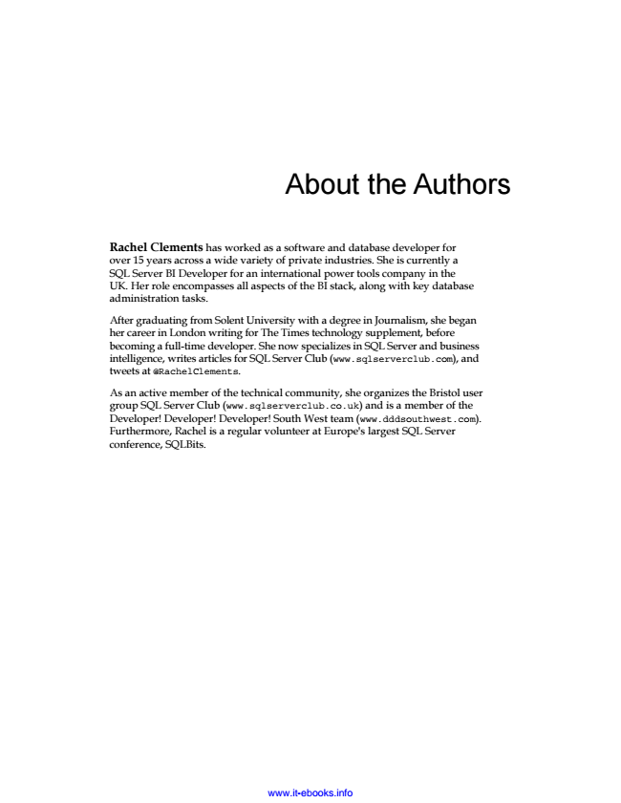

About the Authors

Rachel Clements has worked as a software and database developer for over 15 years across a wide variety of private industries. She is currently a SQL Server BI Developer for an international power tools company in the UK. Her role encompasses all aspects of the BI stack, along with key database administration tasks.

After graduating from Solent University with a degree in Journalism, she began her career in London writing for The Times technology supplement, before becoming a full-time developer. She now specializes in SQL Server and business intelligence, writes articles for SQL Server Club (www.sqlserverclub.com), and tweets at @RachelClements.

As an active member of the technical community, she organizes the Bristol user group SQL Server Club (www.sqlserverclub.co.uk) and is a member of the Developer! Developer! Developer! South West team (www.dddsouthwest.com). Furthermore, Rachel is a regular volunteer at Europe's largest SQL Server conference, SQLBits.

www.it-ebooks.info

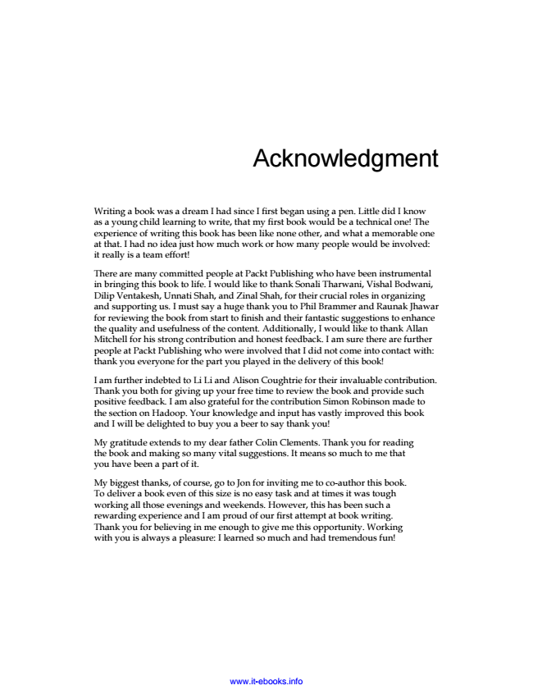

Acknowledgment

Writing a book was a dream I had since I first began using a pen. Little did I know as a young child learning to write, that my first book would be a technical one! The experience of writing this book has been like none other, and what a memorable one at that. I had no idea just how much work or how many people would be involved: it really is a team effort!

There are many committed people at Packt Publishing who have been instrumental in bringing this book to life. I would like to thank Sonali Tharwani, Vishal Bodwani, Dilip Ventakesh, Unnati Shah, and Zinal Shah, for their crucial roles in organizing and supporting us. I must say a huge thank you to Phil Brammer and Raunak Jhawar for reviewing the book from start to finish and their fantastic suggestions to enhance the quality and usefulness of the content. Additionally, I would like to thank Allan Mitchell for his strong contribution and honest feedback. I am sure there are further people at Packt Publishing who were involved that I did not come into contact with: thank you everyone for the part you played in the delivery of this book!

I am further indebted to Li Li and Alison Coughtrie for their invaluable contribution. Thank you both for giving up your free time to review the book and provide such positive feedback. I am also grateful for the contribution Simon Robinson made to the section on Hadoop. Your knowledge and input has vastly improved this book and I will be delighted to buy you a beer to say thank you!

My gratitude extends to my dear father Colin Clements. Thank you for reading the book and making so many vital suggestions. It means so much to me that you have been a part of it.

My biggest thanks, of course, go to Jon for inviting me to co-author this book. To deliver a book even of this size is no easy task and at times it was tough working all those evenings and weekends. However, this has been such a rewarding experience and I am proud of our first attempt at book writing. Thank you for believing in me enough to give me this opportunity. Working with you is always a pleasure: I learned so much and had tremendous fun!

www.it-ebooks.info

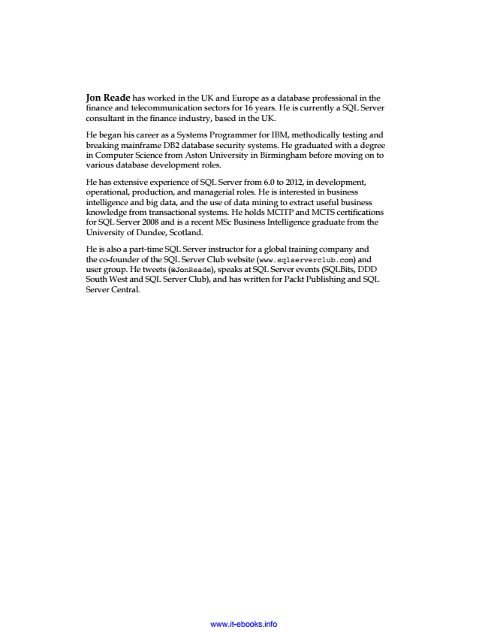

Jon Reade has worked in the UK and Europe as a database professional in the finance and telecommunication sectors for 16 years. He is currently a SQL Server consultant in the finance industry, based in the UK.

He began his career as a Systems Programmer for IBM, methodically testing and breaking mainframe DB2 database security systems. He graduated with a degree in Computer Science from Aston University in Birmingham before moving on to various database development roles.

He has extensive experience of SQL Server from 6.0 to 2012, in development, operational, production, and managerial roles. He is interested in business intelligence and big data, and the use of data mining to extract useful business knowledge from transactional systems. He holds MCITP and MCTS certifications for SQL Server 2008 and is a recent MSc Business Intelligence graduate from the University of Dundee, Scotland.

He is also a part-time SQL Server instructor for a global training company and the co-founder of the SQL Server Club website (www.sqlserverclub.com) and user group. He tweets (@JonReade), speaks at SQL Server events (SQLBits, DDD South West and SQL Server Club), and has written for Packt Publishing and SQL Server Central.

www.it-ebooks.info

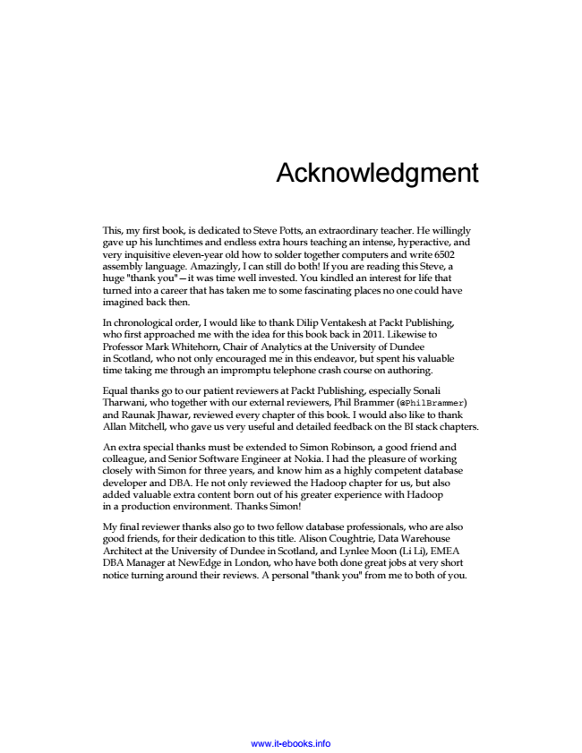

Acknowledgment

This, my first book, is dedicated to Steve Potts, an extraordinary teacher. He willingly gave up his lunchtimes and endless extra hours teaching an intense, hyperactive, and very inquisitive eleven-year old how to solder together computers and write 6502 assembly language. Amazingly, I can still do both! If you are reading this Steve, a huge "thank you"—it was time well invested. You kindled an interest for life that turned into a career that has taken me to some fascinating places no one could have imagined back then.

In chronological order, I would like to thank Dilip Ventakesh at Packt Publishing, who first approached me with the idea for this book back in 2011. Likewise to Professor Mark Whitehorn, Chair of Analytics at the University of Dundee in Scotland, who not only encouraged me in this endeavor, but spent his valuable time taking me through an impromptu telephone crash course on authoring.

Equal thanks go to our patient reviewers at Packt Publishing, especially Sonali Tharwani, who together with our external reviewers, Phil Brammer (@PhilBrammer) and Raunak Jhawar, reviewed every chapter of this book. I would also like to thank Allan Mitchell, who gave us very useful and detailed feedback on the BI stack chapters.

An extra special thanks must be extended to Simon Robinson, a good friend and colleague, and Senior Software Engineer at Nokia. I had the pleasure of working closely with Simon for three years, and know him as a highly competent database developer and DBA. He not only reviewed the Hadoop chapter for us, but also added valuable extra content born out of his greater experience with Hadoop in a production environment. Thanks Simon!

My final reviewer thanks also go to two fellow database professionals, who are also good friends, for their dedication to this title. Alison Coughtrie, Data Warehouse Architect at the University of Dundee in Scotland, and Lynlee Moon (Li Li), EMEA DBA Manager at NewEdge in London, who have both done great jobs at very short notice turning around their reviews. A personal "thank you" from me to both of you.

www.it-ebooks.info

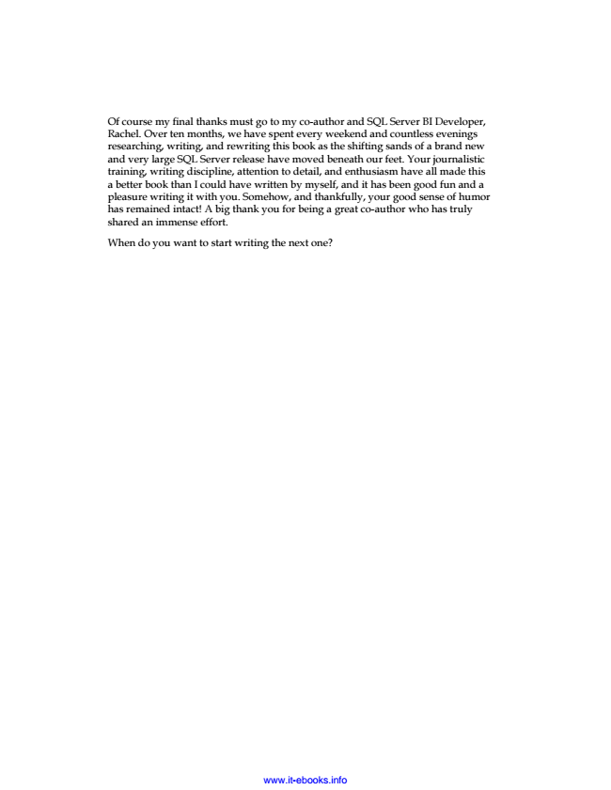

Of course my final thanks must go to my co-author and SQL Server BI Developer, Rachel. Over ten months, we have spent every weekend and countless evenings researching, writing, and rewriting this book as the shifting sands of a brand new and very large SQL Server release have moved beneath our feet. Your journalistic training, writing discipline, attention to detail, and enthusiasm have all made this a better book than I could have written by myself, and it has been good fun and a pleasure writing it with you. Somehow, and thankfully, your good sense of humor has remained intact! A big thank you for being a great co-author who has truly shared an immense effort.

When do you want to start writing the next one?

www.it-ebooks.info

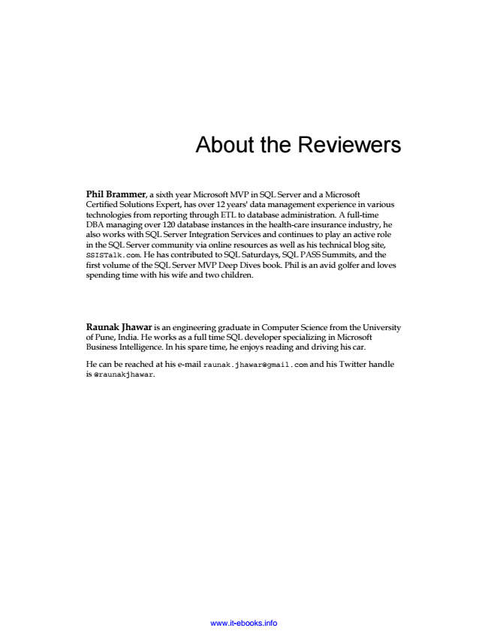

About the Reviewers

Phil Brammer, a sixth year Microsoft MVP in SQL Server and a Microsoft Certified Solutions Expert, has over 12 years' data management experience in various technologies from reporting through ETL to database administration. A full-time DBA managing over 120 database instances in the health-care insurance industry, he also works with SQL Server Integration Services and continues to play an active role in the SQL Server community via online resources as well as his technical blog site, SSISTalk.com. He has contributed to SQL Saturdays, SQL PASS Summits, and the first volume of the SQL Server MVP Deep Dives book. Phil is an avid golfer and loves spending time with his wife and two children.

Raunak Jhawar is an engineering graduate in Computer Science from the University of Pune, India. He works as a full time SQL developer specializing in Microsoft Business Intelligence. In his spare time, he enjoys reading and driving his car.

He can be reached at his e-mail raunak.jhawar@gmail.com and his Twitter handle is @raunakjhawar.

www.it-ebooks.info